YEAR 11 GENERAL HUMAN BIOLOGY

Name: ____________________________
Task 10: Human reproduction and contraceptives test

Multiple Choice 15 Marks
Short Answer 30 Marks
Total 45 Marks

Part 1: Multiple Choice (15 marks)
1 Which of the following are secondary sexual characteristics of the human male?
a. Development of ovaries.
- Hair growth around genitalia.
- Breast development.
- Development of testes.

2. A zygote is formed after the union of two:

- ova.
- gametes.
- germ cells.
- spermatocytes.

3. The advantage of the testes being suspended outside the body in the scrotum is they are:

- better protected.
- kept free from antibodies produced by the lymphatic system.
- at a suitable temperature for sperm production.
- given better support during exercise.

4. What hormone is detected by a pregnancy test?

- Follicle stimulating hormone.
- Lutenising hormone.
- Progesterone.
- Human chorionic gonadotropin.

5. What hormone is secreted from a structure in the ovary?

- Follicle stimulating hormone.
- Lutenising hormone.
- Progesterone.
- Human chorionic gonadotropin.

The next two questions refer to the following diagram.

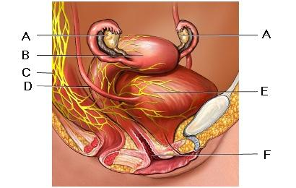

6. Production of ova occurs in:

- A.
- B.
- E.
- F.

7. Implantation of the fertilized egg occurs in:

- A.
- B.
- D.
- E.

8. What hormone causes ovulation?

- Follicle stimulating hormone.
- Lutenising hormone.
- Progesterone.
- Human chorionic gonadotropin.

The next two questions refer to the following diagram.

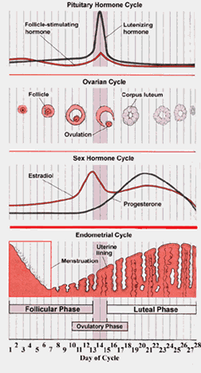

9. Fertilization could occur on days:

- 1 – 5.
- 9 – 14.
- 14 – 19.
- 24 – 28.

10. On which day did menstruation commence?

- Day 1.
- Day 5.
- Day 14.
- Day 28.

11. Which of the following is not a barrier method of contraception:

- Condoms
- Tubal ligation
- Diaphragm
- IUD

- Which of the following have the highest success rate in preventing against pregnancy?

- Implanon
- Combined contraceptive pill
- Condoms
- Mini-pill

13. The external genitalia of the female (vulva) includes:

- clitoris, vagina, labia
- cervix, labia minora, labia majora
- labia minora, labia majora, clitoris
- vagina, labia, cervix

14. Which of the following is false?

- Females start producing gametes before they are born
- Males can produce an unlimited number of gametes
- Females have a fixed number of gametes
- Males can produce gametes from birth until death

15. Which of the following is NOT a phase in the uterine cycle?

- Menstruation
- Follicular
- Secretory
- Proliferative

END OF MULTIPLE CHOICE SECTION
SHORT ANSWER

The next question refers to the diagram below.

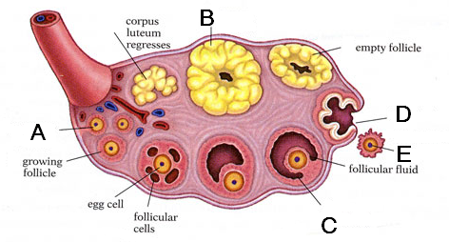

1. a. What event does E represent? (1 mark) ___________________

b. What is structure B called? (1 marks) ____________________

2. Give two differences between sperm production (spermatogenesis) and ova production (oogenesis) (2 marks)
____________________________________________________________________________________________________________________________________________________________________________________________________________________________________________________________________________

3. The diagram below illustrates the male reproductive system.

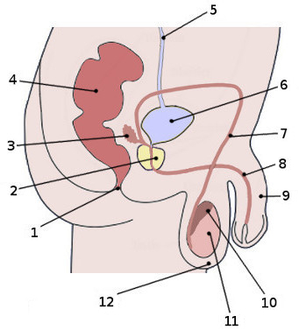

Name the following structures. (6 marks)

1 _________________________________________

3 _________________________________________

7 _________________________________________

8 _________________________________________

10 _________________________________________

11 ________________________________________

4. Describe what happens during the menstrual cycle in the uterus and ovary. Include the changes which are occurring, and the names of the hormones which are causing those changes.

a. Uterus (5 marks)
Before ovulation: ____________________________________________________________________________________________________________________________________________________________________________________________________________________________________________________________________________

After ovulation: ____________________________________________________________________________________________________________________________________________________________________________________________________________________________________________________________________________

b. Ovary (5 marks)
Before ovulation: ____________________________________________________________________________________________________________________________________________________________________________________________________________________________________________________________________________

After ovulation: ____________________________________________________________________________________________________________________________________________________________________________________________________________________________________________________________________________

6. Referring to the following diagram to answer the questions below.

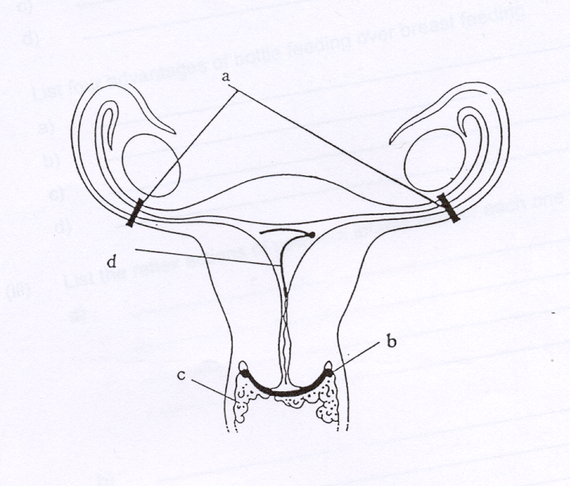
Name each method of contraception indicated by the letters and explain how they work. (4 marks)
A__________________________________________________________________
___________________________________________________________________
___________________________________________________________________
___________________________________________________________________

D__________________________________________________________________
___________________________________________________________________
___________________________________________________________________
___________________________________________________________________

- Give three reasons why a female might choose to use condoms instead of the contraceptive pill. (3 marks)
1__________________________________________________________________
___________________________________________________________________
___________________________________________________________________

2__________________________________________________________________
___________________________________________________________________
___________________________________________________________________

3__________________________________________________________________
___________________________________________________________________
___________________________________________________________________

- Describe three ways in which a hormonal contraceptive prevents pregnancy in the female. (3 marks)
1__________________________________________________________________
___________________________________________________________________
___________________________________________________________________

2__________________________________________________________________
___________________________________________________________________
___________________________________________________________________

3__________________________________________________________________
___________________________________________________________________
___________________________________________________________________

GEHBY Task 10:
Human Reproduction and contraceptives test
SCORES:
MC: /15

SA: /30

TOTAL: /45

_______ %

NAME:_____________________________

TEACHER:__________________________

DATE:______________________________

Section A: Multiple choice (15 Marks)
Answer all questions by circling the most correct answer on the multiple choice answer sheet.

1. a b c d 14. a b c d
2. a b c d 15. a b c d
3. a b c d
4. a b c d
5. a b c d
6. a b c d
7. a b c d
8. a b c d
9. a b c d
10. a b c d
11. a b c d
12. a b c d
13. a b c d

